Excercise 10.1
(a) First, write the delay function. This function should take a single input, the number of seconds to delay for, and be called from the main program every time there is a pause required.
(b) Then write the draw pixel function. This function should take two inputs: the color of the pixel to draw, and the time delay between on and off. This function should also call the delay function to insert the pauses between on and off.
(c) When you implemented draw pixel, what did you have to do with LR to make it work? Why?
In the drawpixel function, we must save the Link Register (LR) onto the stack before calling another function (delay), and restore it afterwards.
This is because the BL instruction overwrites LR with a new return address. When drawpixel calls delay, LR is overwritten, and without saving it, the original return address (back to main) would be lost.
By using PUSH {LR} before the call and POP {LR} before returning, we preserve the correct return address and ensure the program returns to the correct location.
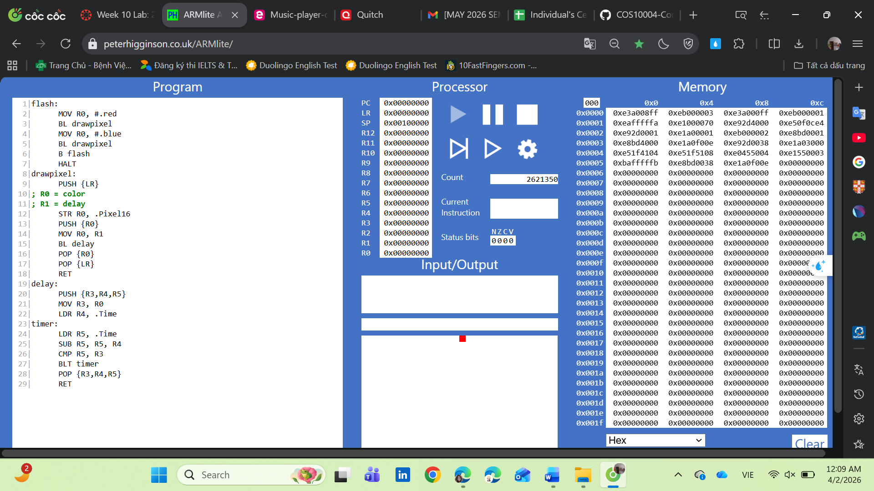
When you're happy with your solution, show your tutor the solution you have written and demonstrate it. Take a screenshot and include it, and provide your answers in your solution document.
Excercise 10.2
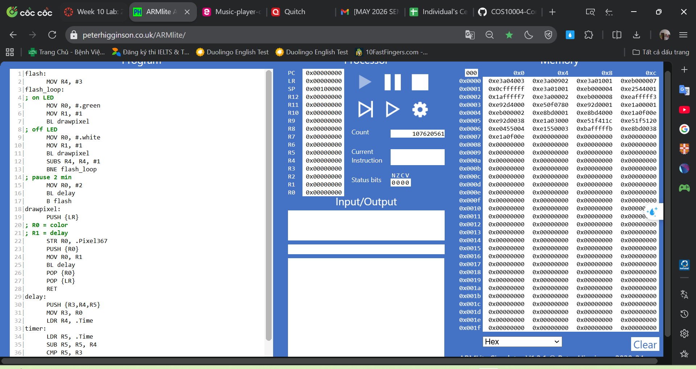
Show your solution to your tutor. Take a screenshot and include it in your solution document.
Excercise 10.3
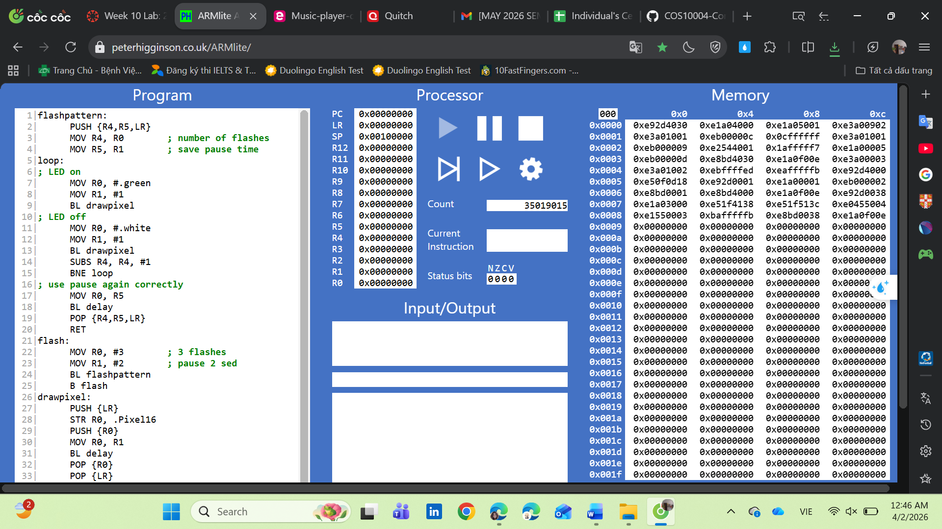
Show your solution to your tutor. Take a screenshot and include it in your solution document

